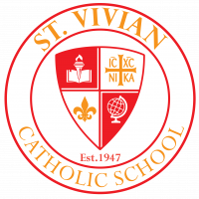 Sabre Scoop Friday,November 18, 2022

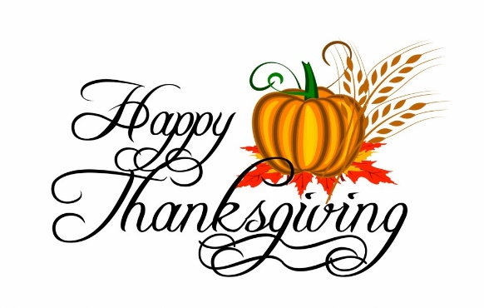From our family to yours, have a happy and peaceful Thanksgiving! Enjoy time with family and friends! Thank you for being a part of St. Vivian!
There will be no school Wednesday, November 23, Thursday, November 24, or Friday, November 25. Classes will resume Monday, November 28. There will be no Sabre Scoop next Friday, November 25.

Report Cards

Second trimester ended last Friday. Teachers completed grading assignments and tabulated grades. Report cards were sent home today, November 18. Please check the report card, sign a copy, and return the copy to the homeroom teacher. This way we know that you received a copy. Thank you!

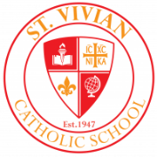Sabre Spirit Wear Day

Our next Sabre Spirit Wear day will be Friday, December 2. Students may be out of uniform and wear jeans, sweats, joggers, etc. as long as they wear a St. Vivian t-shirt or sweatshirt.

Jingle Bell Shop
Save the Date: Jingle Bell Shop will be December 7th and 8th
What is Jingle Bell Shop? It is a fun opportunity for students to shop for Christmas gifts for their loved ones on their own during school hours. PTA has run this event for years and subsidizes the costs of the goods so that all kids can afford to purchase items. Almost all items cost from $1 - $5 (no tax). Students will be able to purchase up to 5 items this year. A shopping list will be sent home with the kids closer to the event.
ELVES NEEDED: We need your help to make Jingle Bell Shop a festive and joyful event for the kids. Please check out the sign-up genius to volunteer to help the kids shop, cashier or wrap gifts: https://www.signupgenius.com/go/20f0a44a8af2ca1ff2-jingle4

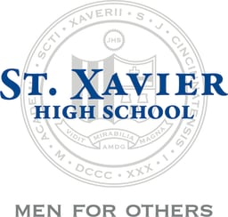Congratulations to our graduates who attend St. Xavier High School and made the honor roll! We’re very proud of their accomplishments!

The following St. Vivian graduates have received Honors their 1st quarter at St. Xavier…

First Honors
Dimitri Bermudez 9th
George Brass 12th
Max Brass 9th
Dominic Cole 11th
Jordan Ingram 11th
Eric Schurdak Jr. 10th
Benjamin Strotman 12th
Jack Zestermann 12th

Second Honors
Evan Fleetwood 12th
Braydon Myers 12th
Domenic Rios Cruz 9th

Sabre Christmas Program 2022
Join us on Thursday, December 15 at 7:00P.M. in the church for our Christmas program. This year ALL grades will have a part to showcase their talent! We ask that students be in their homerooms by 6:40P.M. Students should wear Christmas attire or red/green – no ripped jeans or sweatpants please. Students are encouraged to dress up for the occasion.

