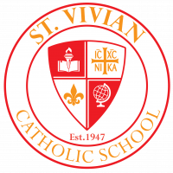 Sabre Scoop Friday, December 2, 2022

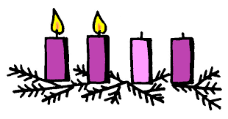HAPPY ADVENT!

The Roman Catholic Church's liturgical year begins with Advent and is the season encompassing the four Sundays (and weekdays) leading up to the celebration of Christmas. This is a very special time for us all as we prepare our hearts and minds for the anniversary of Our Lord’s birth on Christmas. We use wreaths and candles, among other things, to symbolize our faith and good will. The Advent wreath made of evergreen branches symbolizes continuous life. The circle shape of the wreath signifies the eternity of God with no beginning and no end. It is the everlasting life we find in Christ.

Each week of Advent we light a colored candle among the wreath at Mass to celebrate a different meaning of Advent. There are three purple candles symbolizing prayer, penance, and sacrifice and one pink candle symbolizing joy. We celebrate HOPE the first Sunday of Advent as we await the return of our Lord someday. The second week of Advent celebrates PEACE, representing the Holy Family and their journey to Bethlehem. The third week celebrates JOY to remind us of the joy of Christ’s birth. Finally, the fourth week of Advent celebrates LOVE to remind us of the message of the angels, “on earth peace, good will toward men.”

As we enter the second week of Advent, we want to express our gratitude for our families and parishioners at St. Vivian. We celebrate our faith each day and remember the journey the Holy Family made for us. We hope that your Advent, Christmas, and the New Year will be full of Hope, Joy, Love, and Peace on Earth!

Jingle Bell Shop
Save the Date: Jingle Bell Shop will be December 7th and 8th
What is Jingle Bell Shop? It is a fun opportunity for students to shop for Christmas gifts for their loved ones on their own during school hours. PTA has run this event for years and subsidizes the costs of the goods so that all kids can afford to purchase items. Almost all items cost from $1 - $5 (no tax). Students will be able to purchase up to 5 items this year. A shopping list will be sent home with the kids closer to the event.
ELVES NEEDED: We need your help to make Jingle Bell Shop a festive and joyful event for the kids. Please check out the sign-up genius to volunteer to help the kids shop, cashier or wrap gifts: https://www.signupgenius.com/go/20f0a44a8af2ca1ff2-jingle4

Sabre Christmas Program 2022
Join us on Thursday, December 15 at 7:00 P.M. in the church for our Christmas program. This year ALL grades will have a part to showcase their talent! We ask that students be in their homerooms by 6:40 P.M. Students should wear Christmas attire or red/green – no ripped jeans or sweatpants please. Students are encouraged to dress up for the occasion.

November Virtue Award Recipients
In November we celebrated the virtue of Humility. Each homeroom chose a student that best exhibited the trait of being modest and humble. We’d like to congratulate those students who demonstrated their commitment to humility. We’re very proud of them!

Kindergarten- Serenity Fugikawa
1st – Aubree Ridley
2nd- Salvador Serano-Trejo
3rd – Zada Kahlberg
4th – Jacob Martinez – Otamendi
5th – Keven Salinas-Berrera
6th Cotes – Julian Ingram
6th Franzosa – Danya Romine
7th – Breann Myers
8th Kolis – Amira Ramahi
8th Surber – Cindy Jimenez Escobedo

No PTA Mtg. in Dec.

Due to the short time that we are in school during December, there will be no PTA meeting this month. PTA meetings will resume in January.

Sabre Spirit Wear
We’d like to give a big thank you to our PTA for purchasing spirit wear t-shirts for everyone this year! Students may wear these shirts the first Friday of each month with jeans, sweats, etc. What a generous and wonderful St. Vivian PTA gift!!! We are so grateful!

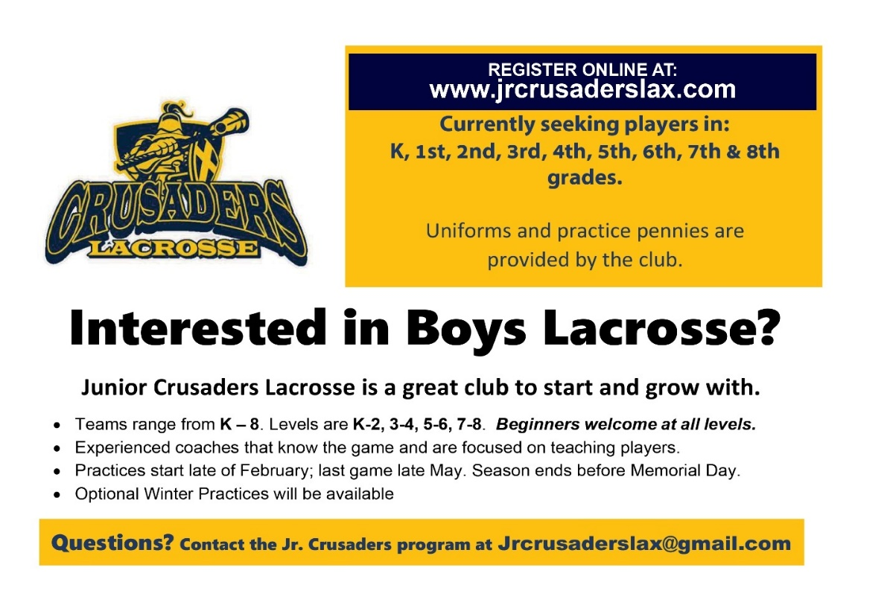

Mercy McAuley Grade School Basketball Night
Future Wolves of all grade levels are invited to Mercy McAuley’s Grade School Basketball Night on Monday, December 12. The varsity game begins at 7:30 p.m. All future Wolves will receive free admission to the game, plus snacks and giveaways. Grade School festivities will begin at 7 p.m.

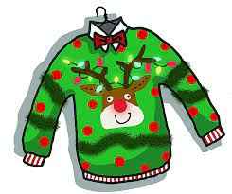”Ugly” Christmas Sweater or Christmas Attire

On December 9, Roger Bacon High School will be performing a holiday concert for our Sabres at 1:00. To help everyone enjoy the afternoon and feel festive, we will hold a special out of uniform day in which students may wear their favorite “ugly” Christmas sweater or just plain Christmas attire. Let’s show Roger Bacon that we aren’t Grinches and wear our favorite holiday

