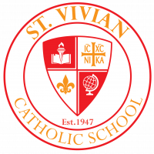 **Sabre Scoop Friday, December 9, 2022**

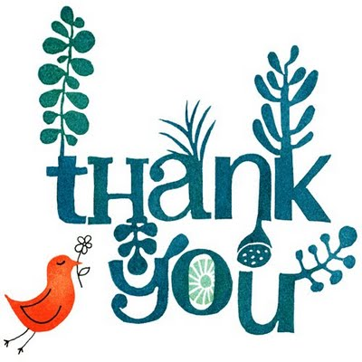**Jingle Bell Shop**

**We want to extend our heartfelt gratitude for the PTA and Jingle Bell Shop! T’is the season for giving and without their efforts, we wouldn’t be able to let our students shop. We’d like to give special recognition to Mrs. McCabe and Mrs. Vondrell who shopped for, organized, and directed the Jingle Bell Shop! We also want to thank all our helper “elves” who helped students shop and wrap presents for family members. We every much appreciate all of you! You have made our season brighter!**

**Jingle Bell Shoppe Wrap-Up**

Jingle Bell Shoppe was a wonderful, fun time for all the kids.  Thank you to the many elves we had behind the scenes and out front helping the kids:  Roxane Schellingerhout, Kristy Lanier, Megan Haber, Rohan & Melinda Dighe, Janae Walker, Jenifer Humdy, Elizabeth Hutson, Kelly & Anthony Braun, Allison Myers, Danielle James, Joan Ramahi, Carol Morison, Pauline Banta and Maureen Richard.  We really appreciate all of you volunteering and helping out!

-Merry Christmas!

-Denise & Carly



Join us to cheer on our 8th grade Sabres! The 8th grade girls play at 6:00 and the 8th grade boys play at 7:00. Wear your favorite Christmas attire and help us spread some cheer!

 **Medication**

As a reminder, do not send any medication – even over the counter medication – with students to school. We know that students have been ill, but students can’t have medication at school without a doctor’s note and in original packaging. ALL medication must go through the nurse or office at all times. While one child may not have any negative effects taking a medication, someone else might. We have to be very careful to keep all medication away from students who do not have a prescription for it. Please keep all allergy, cough, aspirin, etc. medication at home and only dispense it at home. Thank you for your understanding!

Sabre Dance Team Christmas Showcase

Join us on Thursday, December 15 at 6:00 in the gym for performances by our Sabre Dance Team! All are invited to attend. The performances will be before our school Christmas program and will highlight all of our tremendous, talented, dancers!

Sabre Christmas Program 2022

Join us on Thursday, December 15 at 7:00 P.M. in the church for our Christmas program. This year ALL grades will have a part to showcase their talent! We ask that students be in their homerooms by 6:40 P.M. Students should wear Christmas attire or red/green – no ripped jeans or sweatpants please. Students are encouraged to dress up for the occasion.

RB3

We want to thank Roger Bacon High School and their band RB3 for treating us to a Christmas concert today! It was such a nice way to end the week and prepare for Christmas! A big round of applause for the tremendous job they did!!!

No PTA Mtg. in Dec.

Due to the short time that we are in school during December, there will be no PTA meeting this month. PTA meetings will resume in January.

 **Mercy McAuley Grade School Basketball Night**

Future Wolves of all grade levels are invited to Mercy McAuley’s Grade School Basketball Night on Monday, December 12. The varsity game begins at 7:30 p.m. All future Wolves will receive free admission to the game, plus snacks and giveaways. Grade School festivities will begin at 7 p.m.

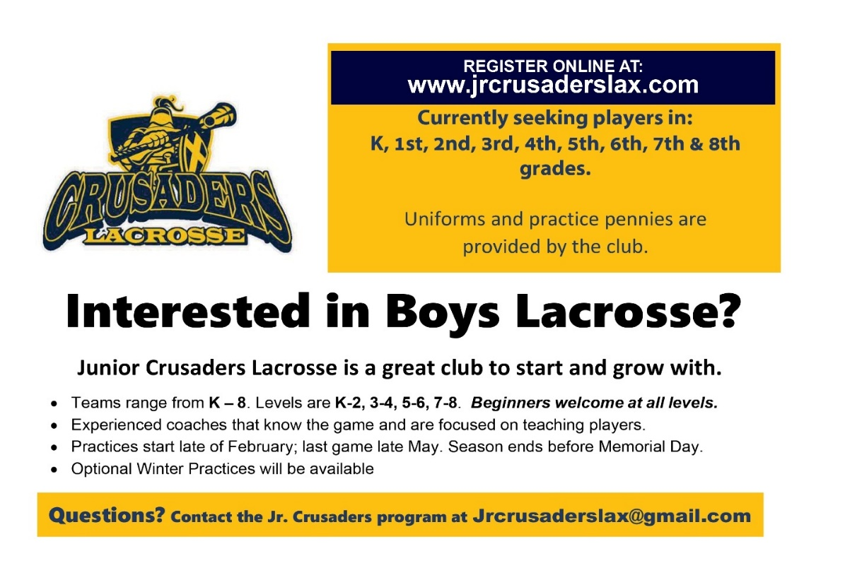

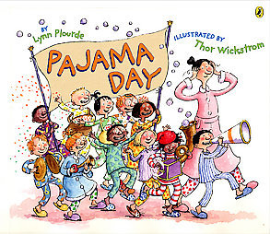 Pajama Day!!!

Since we will be out late on Thursday evening for the Christmas concert, we’re going to have a pajama day on Friday, December 16! We’ll end our time before break in comfort!

Students may wear pajamas or sweats and be out of uniform. We will go outside for recess so students must wear gym shoes – no slippers. Please make sure students dress warm enough – no shorts. If girls wear nightgowns, they must wear leggings/sweatpants underneath. All

pajamas must be appropriate for school – no spaghetti straps, short nightgowns, etc.

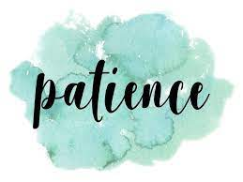December Virtue

Our virtue this month is patience. As we wait for the coming of Christ’s birthday, we’ll be practicing patience and imitating our 3 saints of the month – St. Monica, St. Isaac Jogue, and St. Rita of Cascia. Please help us to teach our Sabres this important virtue. We’ll be recognizing students who exhibit this virtue most when we return from Christmas break.